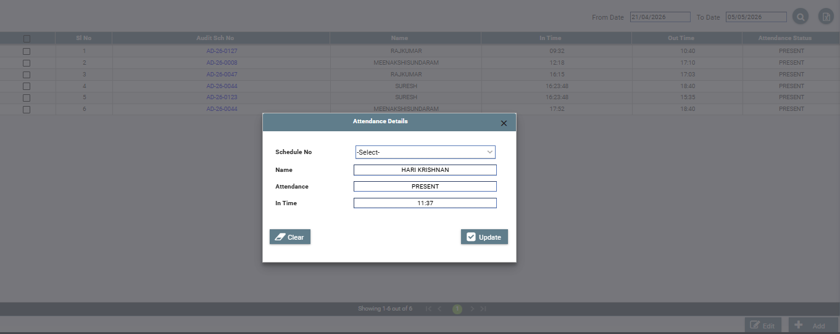
SOP: Audit Attendance Management Module
1. Objective
To track and manage audit attendance for auditors/auditees linked to audit schedules, including:
- In Time / Out Time
- Attendance Status (Present/Absent)
- Schedule-wise tracking

2. Module Structure
Pages
- Summary Page (Attendance List)
- Creation / Update Popup (Attendance Entry Form)

3. Summary Page (Attendance List View)
3.1 Purpose
Display attendance records for audit schedules.

3.2 Fields to Display
- Sl No
- Audit Schedule No
- Name
- In Time
- Out Time
- Attendance Status (Present / Absent)

3.3 Filters
- From Date
- To Date
- Schedule No
- Name
- Attendance Status

3.4 Features
Search
- Date range-based filtering
- Quick search by Name / Schedule No

Actions
- Add (+) → Open Attendance Entry Popup
- Edit → Open selected record in popup
- Bulk Select (Checkbox) → Future enhancement

Pagination
- 10 / 20 / 50 records per page

4. Creation / Update Page (Popup Form)
4.1 Purpose
To mark or update attendance for a selected audit schedule.

4.2 Fields
Field | Type | Mandatory | Description
Schedule No | Dropdown | Yes | List of active audit schedules
Name | Auto-filled | Yes | Based on selected schedule/user
Attendance | Dropdown | Yes | Present / Absent
In Time | Time Picker | Yes | Entry time
Out Time | Time Picker | Optional | Exit time

4.3 Buttons
Update
- Validate inputs
- Save/update attendance record
- Close popup
- Refresh summary grid
Clear
- Reset all fields

5. Validations
- Schedule No → Required
- Name → Required (auto-filled, non-editable)
- Attendance → Required
- In Time → Required if Present
- Out Time:
  - Must be greater than In Time
  - Optional if attendance is Absent

6. Business Logic
- When Schedule No is selected:
  - Fetch assigned users (Auditor/Auditee)
  - Populate Name automatically
- Default Behavior:
  - Attendance = PRESENT (optional default)
  - In Time = Current system time (optional)
- If Attendance = ABSENT:
  - Disable In Time / Out Time fields
- Prevent duplicate entry:
  - One attendance per user per schedule per day

7. Database Design
7.1 Table: audit_attendance
- id (PK)
- schedule_id (FK)
- user_id (FK)
- attendance_status (PRESENT / ABSENT)
- in_time
- out_time
- attendance_date
- created_by
- created_date
- updated_by
- updated_date

8. UI Behavior (Based on Screenshot)
- Popup modal centered
- Clean form layout
- Read-only fields:
  - Name
- Dropdown for Schedule No
- Buttons:
  - Left → Clear
  - Right → Update

9. Workflow
- User opens Attendance Module
- Views attendance list
- Clicks Add / Edit
- Popup opens
- Selects Schedule No
- Name auto-populates
- Enters attendance details
- Clicks Update
- Record saved and reflected in grid

10. Status Logic
Condition | Status
In Time exists | PRESENT
No entry | ABSENT

11. Permissions
Role | Access
Admin | Full Access
Auditor | Mark Attendance
Viewer | Read Only

12. Deliverables for Developer
- Summary Page UI
- Attendance Popup UI
- Schedule-user mapping logic
- Validation rules
- Database table
- Real-time refresh after update

